OOP FINAL PROJECT

NAME: MUHAMMAD SULEMAN ELAHI
SAP ID: 70172884
SECTION: H

Abstract
Air pollution and smog are growing environmental concerns, causing health hazards and environmental degradation. This project presents a real-time Air Quality and Smog Detection System using an Arduino Uno and an MQ-135 gas sensor.
The system monitors air quality levels continuously and provides visual and audible alerts when pollution exceeds safe thresholds. The software is designed using Object-Oriented Programming (OOP) principles to ensure modularity, maintainability, and scalability.
The project can be extended for IoT applications, cloud logging, and predictive analysis, making it suitable for smart cities, industrial safety, and indoor air quality monitoring.

1. Introduction
Air pollution is a serious environmental problem affecting human health worldwide. Detecting poor air quality early can prevent health issues and help take corrective measures.
The MQ-135 gas sensor is widely used to detect gases like CO₂, NH₃, NOx, and smoke. Coupled with an Arduino microcontroller, it can form a low-cost air quality monitoring system.
This project uses OOP in C++ to structure the software into reusable, modular classes that simulate real-world embedded systems design.

2. Objectives
- Detect poor air quality and smog in real-time.
- Provide visual (LED) and audio (buzzer) alerts.
- Implement the system using OOP concepts for better maintainability.
- Make the design scalable and reusable for future extensions.
- Demonstrate practical embedded system skills for a final-year project.

3. Hardware Components
Component | Description
Arduino Uno | Microcontroller for controlling sensors and outputs
MQ-135 Gas Sensor | Detects CO₂, NH₃, NOx, and smoke
Green LED | Indicates safe air quality
Red LED | Indicates bad air or smog
Buzzer | Provides audio alert when air quality is poor
Resistors (220Ω) | Protects LEDs from overcurrent
Breadboard & Jumper Wires | For assembling the circuit

4. Software Tools
- Arduino IDE (for coding and uploading)
- C++ (OOP)
- Serial Monitor (for displaying real-time sensor data)

5. System Design (OOP Approach)

5.1 Classes
- GasSensor
  - Reads analog sensor values from MQ-135.
- AlertSystem
  - Controls LEDs and buzzer for good or bad air alerts.
- AirQualityMonitor
  - Analyzes sensor values and decides whether air is good or bad.

5.2 Class Diagram

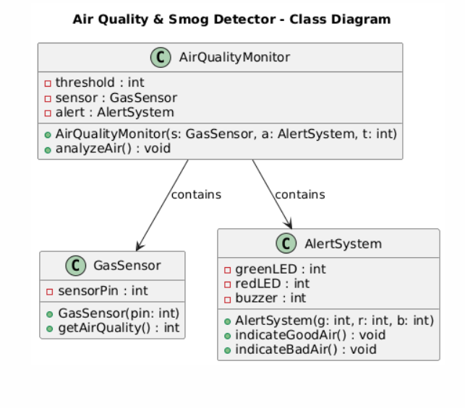

5.3 OOP Concepts Used
- Encapsulation: Each class hides its internal data.
- Abstraction: High-level methods (analyzeAir) hide hardware details.
- Composition: AirQualityMonitor has-a GasSensor and AlertSystem.
- Reusability: Classes can be reused in other Arduino projects or IoT applications.

- Circuit Design

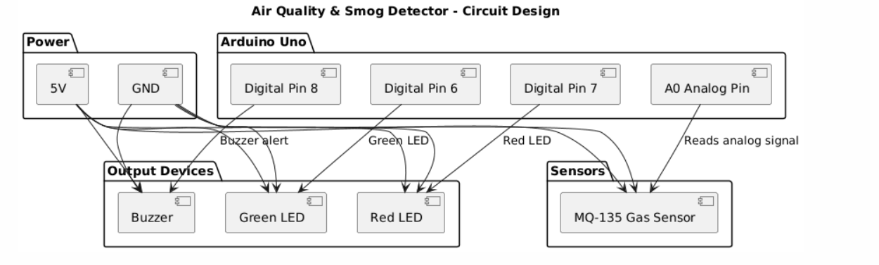
Pin Configuration:
Component | Arduino Pin
MQ-135 AOUT | A0
Green LED | 6
Red LED | 7
Buzzer | 8

7. Air Quality Logic
Sensor Value | Status
< 400 | Good Air
≥ 400 | Bad Air / Smog
Thresholds can be calibrated according to the environment.
The system updates every 2 seconds.

8. Implementation (Code Overview)
Arduino Sketch Structure (OOP):

class GasSensor {
private:
int sensorPin;

public:
GasSensor(int pin) {
sensorPin = pin;
}

int getAirQuality() {
return analogRead(sensorPin);
}
};

class AlertSystem {
private:
int greenLED;
int redLED;
int buzzer;

public:
AlertSystem(int g, int r, int b) {
greenLED = g;
redLED = r;
buzzer = b;

pinMode(greenLED, OUTPUT);
pinMode(redLED, OUTPUT);
pinMode(buzzer, OUTPUT);
}

void indicateGoodAir() {
digitalWrite(greenLED, HIGH);
digitalWrite(redLED, LOW);
digitalWrite(buzzer, LOW);
}

void indicateBadAir() {
digitalWrite(greenLED, LOW);
digitalWrite(redLED, HIGH);
digitalWrite(buzzer, HIGH);
}
};

class AirQualityMonitor {
private:
GasSensor sensor;
AlertSystem alert;
int dangerThreshold;

public:
AirQualityMonitor(GasSensor s, AlertSystem a, int threshold)
: sensor(s), alert(a) {
dangerThreshold = threshold;
}

void analyzeAir() {
int airValue = sensor.getAirQuality();

Serial.print("Air Quality Reading: ");
Serial.println(airValue);

if (airValue < dangerThreshold) {
Serial.println("Status: GOOD AIR");
alert.indicateGoodAir();
} else {
Serial.println("Status: BAD AIR / SMOG DETECTED");
alert.indicateBadAir();
}

Serial.println("-------------------------");
}
};

GasSensor gasSensor(A0);
AlertSystem alertSystem(6, 7, 8);
AirQualityMonitor airMonitor(gasSensor, alertSystem, 400);

void setup() {
Serial.begin(9600);
Serial.println("Air Quality Monitoring System Initialized");
}

void loop() {
airMonitor.analyzeAir();
delay(2000);
}
Explanation:
- GasSensor reads analog data.
- AlertSystem manages LEDs and buzzer alerts.
- AirQualityMonitor decides air quality and triggers alerts.
- Serial Monitor displays real-time readings for monitoring.

9. Results
Condition | LED | Buzzer | Serial Monitor Output
Good Air | ON | OFF | "Status: GOOD AIR"
Bad Air / Smog | ON | ON | "Status: BAD AIR / SMOG DETECTED"
- The system successfully detects air quality changes.
- Audio and visual alerts help users respond to poor air conditions immediately.

10. Applications
- Indoor air quality monitoring
- Smart homes and smart cities
- Industrial pollution monitoring
- Schools, hospitals, and offices

11. Future Enhancements
- Integration with IoT (ESP32 / NodeMCU) for cloud logging
- LCD/OLED display for direct readings
- Support for PM2.5 and PM10 sensors for more precise air quality
- Mobile app alerts
- Machine learning-based predictive air quality system

12. Conclusion
This project successfully demonstrates a real-time Air Quality & Smog Detection System using Arduino and OOP. The modular design allows easy maintenance and future scalability.
It combines hardware sensing, real-time alerts, and software engineering principles, providing a strong foundation for environmental monitoring systems and smart city applications.

